**DAILY ONLINE ACTIVITIES SUMMARY**

|  |  |  |  |  |  |  |  |
| --- | --- | --- | --- | --- | --- | --- | --- |
| **Date:** | **21/06/20** | | | | **Name:** | **Harshitha M** | |
| **Sem & Sec** | **8th sem, A sec** | | | | **USN:** | **4AL16CS038** | |
| **Online Test Summary** | | | | | | | |
| **Subject** | | **Not conducted** | | | | | |
| **Max. Marks** | |  | | **Score** | |  | |
| **Certification Course Summary** | | | | | | | |
| **Course** | **Introduction to cyber security** | | | | | | |
| **Certificate Provider** | | | **Great Learning** | **Duration** | | | **11.5hrs** |
| **Coding Challenges** | | | | | | | |
| **Problem Statement: C program for swapping two numbers using Bitwise Operator** | | | | | | | |
| **Status: Completed** | | | | | | | |
| **Uploaded the report in Github** | | | | **Yes** | | | |
| **If yes Repository name** | | | | **Harshitha-M** | | | |
| **Uploaded the report in slack** | | | | **Yes** | | | |

Online Test Details:

Certification Course Details:

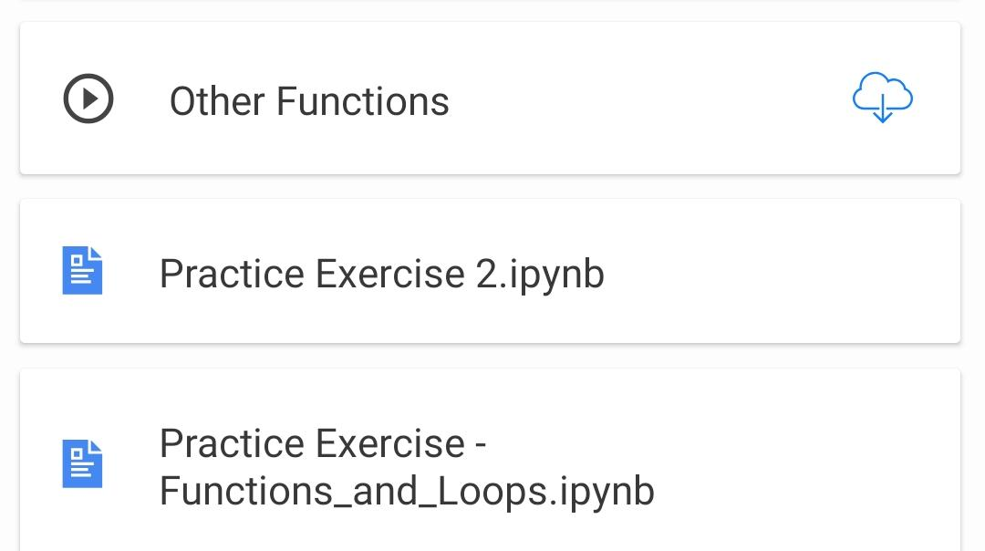

Coding Challenges Details:

#include <stdio.h>

int main() {

int i = 65;

int k = 120;

printf(" value of i=%d k=%d before swapping", i, k);

i = i ^ k;

k = i ^ k;

i = i ^ k;

printf("value of i=%d k=%d after swapping", i, k);

return 0;

}